UDC
H. G. WELLS
Belarusian State University of Transport, Gomel
How to write the paper to “Mechanics” scientific papers
Annotation annotation annotation annotation annotation annotation annotation annotation annotation annotation annotation annotation annotation annotation annotation annotation annotation.
Text: Times New Roman, 10 pt, paragraph indent 5 mm, single line spacing, justified alignment.
Figures should be centered. They must be shown after they are mentioned in the text. Figure caption: Times New Roman, 9 pt.
Figure 1 – The mechanism
Diagrams and graphics must be in black or gray colors. All diagram and graphics lines (figure 2) must be marked. The pictures from MS Word are not advisable.

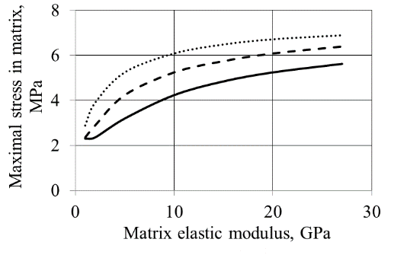
Rebars elastic modulus: –––– 200 GPa; – – – 100 GPa; ∙∙∙∙∙∙∙∙ 50 GPa
Figure 2 – Dependence of concrete maximum stresses on the elasticity modulus of concrete
Tables should be placed after they were referenced in the text. The table text: Times New Roman, 9 pt.
Table 1 – A matrix realization of operations on vectors
Operation name | Defining operations in a vector space | Matrix realization of operation
Addition of vectors
Multiply a vector by a number

Equations must be done in Formulas style (equation 1).
. (1)
Text text text text text text text text text text text text text text text text text text text text text text text text text text text text text text text text text text text text text.
REFERENCES
1 Samios, C. K. Compatibilization of poly(ethylene terephtalate) / C. K. Samios, N. K. Kalfoglou / Polyamide-6 alloys: Mechanical, thermal and morphological characterization // Polymer. – 1999. – Vol. 40. – № 17. – P. 4811–4819.
2 ASM Handbook. Volume 3: Alloy Phase Diagrams. 10 edition. / Edited by: Baker, Hugh; Okamoto, Hiroaki // Materials Park, Ohio: ASM International, 1992. – 512 p.
3 Iron and Steel Industry / The Canadian Encyclopedia // http://www.thecanadianencyclopedia.com/ Accessed at 2010.

